

Progress Report
Nathan Walker

Name:
Project Title:
IFEC Audio Amplifier

Set
Tell us about last week’s goals. How did they go?
three goals to work on this week.

To get all of the possible points for this section, write at least three sentences for each goal. Describe what each goal was and how you accomplished it (or what happened to prevent you from accomplishing it).

Goal #1: In the text box below, describe the goal and the work you did to accomplish it.
Remove and replace switches on the boards. There are two boards that after testing have been determined to have bad switches that need replacing. Once replaced the boards should be good to go.

Status: ☐ Complete ☒ Partially Complete ☐ No Progress

Goal #2: In the text box below, describe the goal and the work you did to accomplish it.
Testing the boards with some increasing power. Once the switches have been replaced the boards are ready to be tested along with the inductor changes. I will be a supporting role helping with any additional hardware problems.

Status: ☐ Complete ☒ Partially Complete ☐ No Progress

Goal #3: In the text box below, describe the goal and the work you did to accomplish it.
Support testing and support and software or testing problems that comes. I designed the PCBs so make sure that signals or expected voltages are where they are while testing after fixing will be important. I will also help fix any additional hardware problems that arise from the switches being fixed.

Status: ☐ Complete ☒ Partially Complete ☐ No Progress

Set three goals to work on next week.

Progress reports are individual assignments. That means you will be setting goals that you yourself intend to accomplish this week. Be specific; set goals that can be completed in one or two weeks.
As you work on your goals, make sure to take at least one picture or screenshot to show what you have done. The picture or screenshot will need to be submitted in your next progress report.
To get all of the possible points for this section, write at least three sentences for each goal. Describe what the goal is and how you plan to accomplish it.

Goal #1:
Remove and replace switches on the boards. There are two boards that after testing have been determined to have bad switches that need replacing. Once replaced the boards should be good to go.

Goal #2:
Testing the boards with some increasing power. Once the switches have been replaced the boards are ready to be tested along with the inductor changes. I will be a supporting role helping with any additional hardware problems.

Goal #3:
Support testing and support and software or testing problems that comes. I designed the PCBs so make sure that signals or expected voltages are where they are while testing after fixing will be important. I will also help fix any additional hardware problems that arise from the switches being fixed.

Visual Communication

Each report must be accompanied by an updated schedule in the form of a Gantt chart. You need to include the version from the previous progress report and the updated chart for next week. Paste them below or save the charts as pdfs and upload them separately.

Each report must also be accompanied by evidence of your work. This can be a photo, screenshot, graph, chart, code snippet, data table, or any other visual evidence that we discuss in class. Paste it below or upload it as a separate file.
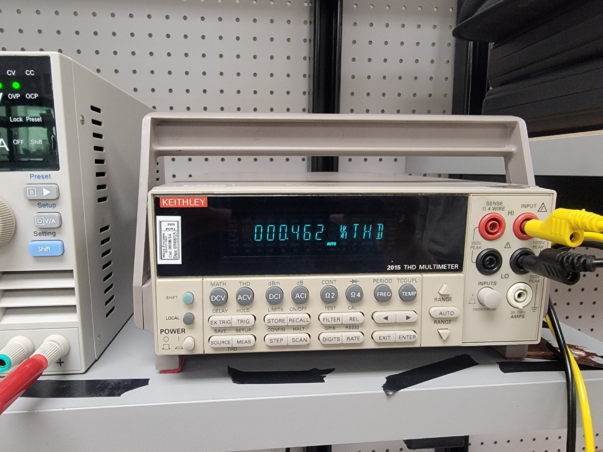
THD measurement from test this week.

